**COMPLEX ENGINEERING PROBLEM**

**Objectives:**

The main objective is to compare load frequency controller:

1. PID controller
2. ANN controller
3. ANFIS (Adaptive Neuro Fuzzy Inference System)

**Load frequency control of single Area system:**

Development of the single area power system includes the combined structure of speed governor, turbine and generator-load models.

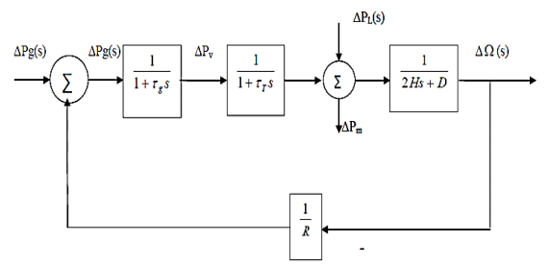

**Figure-1 shows the load frequency diagram of single area system**

In a single area uncontrolled system whenever a load increase takes place it is taken care of by the system in the following three ways.

* Borrowed kinetic energy from the rotating machines of the system.
* Released customer load.
* Increased generation.
* **Literature Review:**

Load frequency control (LFC) is an important aspect of power system operation to maintain system stability by regulating frequency and power balance. LFC ensures that the total generation in the system matches the total load demand, thereby maintaining the frequency within acceptable limits (Jabbari et al., 2018). The LFC system consists of several components, including generators, governor-turbine systems, and load compensating devices. The control of these components is achieved through various controllers that differ in their approach, design, and performance.

PID (proportional-integral-derivative) controller is a widely used feedback control technique for LFC systems. The PID controller adjusts the power output of the generator by continuously monitoring the frequency deviation and its rate of change. The proportional, integral, and derivative terms of the controller adjust the power output in proportion to the error, the accumulated error over time, and the rate of change of error, respectively. PID controllers are simple, robust, and have well-established tuning rules, but their performance may not be optimal in highly nonlinear and uncertain systems.

Artificial neural networks (ANNs) have gained popularity in recent years as a viable alternative to traditional controllers. ANNs can approximate nonlinear mappings between input and output signals, making them suitable for modeling and control of complex systems, including power systems. ANNs have been successfully used for LFC systems, and they offer several advantages, such as adaptability, fault tolerance, and fast response time. However, ANNs require large amounts of training data and are computationally intensive, making them challenging to implement in real-time applications.

Adaptive neuro-fuzzy inference system (ANFIS) is a hybrid intelligent system that combines the strengths of neural networks and fuzzy logic. ANFIS has been applied to LFC systems and has shown promising results in terms of improved performance and reduced computational requirements. ANFIS can adjust its parameters online based on the current system state, making it adaptable to changing operating conditions. ANFIS can also handle uncertainties and nonlinearities in the system and can provide a more accurate and reliable control than PID or ANN controllers.

In summary, LFC is crucial for maintaining system stability, and different controllers can be used to achieve this goal. PID controllers are widely used, while ANN and ANFIS controllers offer promising results in terms of improved performance and adaptability. The choice of controller depends on the system's complexity, performance requirements, and available computational resources.

**Procedure:**

1. Design and implement the Load Frequency Control (LFC) model in MATLAB/Simulink, including the Governor, Turbine, and inertia load.
2. Set up the simulation parameters, including the system frequency and the load demand.
3. Implement a PID controller for the LFC system and select the proportional, integral, and derivative parameters to maintain the system within limits.
4. Simulate the LFC system with the PID controller and analyze the response of the system.
5. Implement an ANN controller for the LFC system and design the controller to achieve sharp and better response.
6. Simulate the LFC system with the ANN controller and analyze the response of the system.
7. Implement an ANFIS controller for the LFC system and design the controller to achieve a faster response time.
8. Simulate the LFC system with the ANFIS controller and analyze the response of the system.
9. Compare the responses of the LFC system with the three different controllers, including the system's stability, frequency deviation, and response time.
10. Present the results in tables and graphs, and draw conclusions about the performance of the different controllers in the LFC system.

* **Case #01:**

Load frequency control using PID controller.

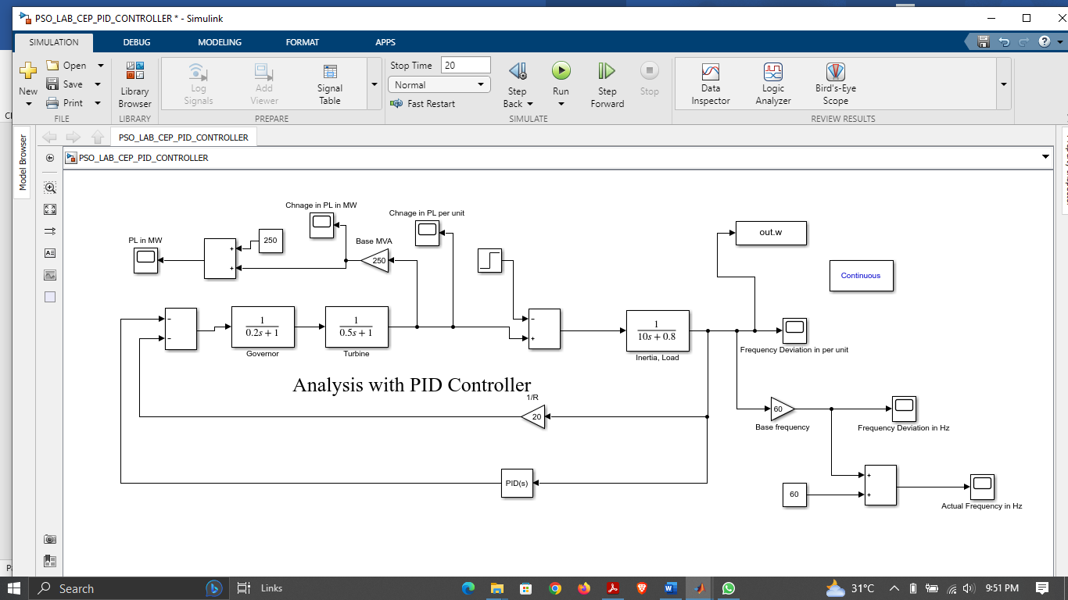

**Figure-2 Simulink model of LFC using PID controller**

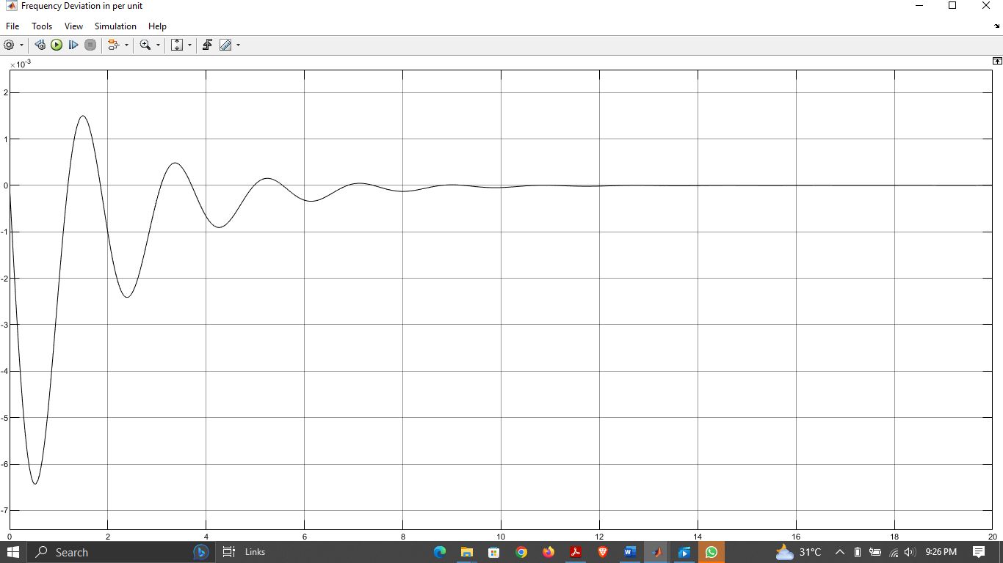

**Figure-3 Frequency Deviation of Load in per unit**

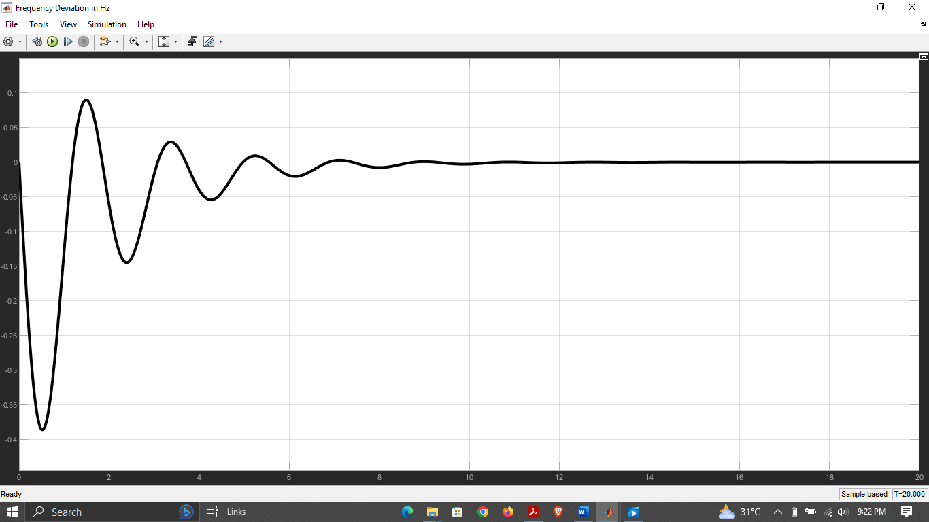

**Figure-4 Frequency Deviation of Load in Hertz**

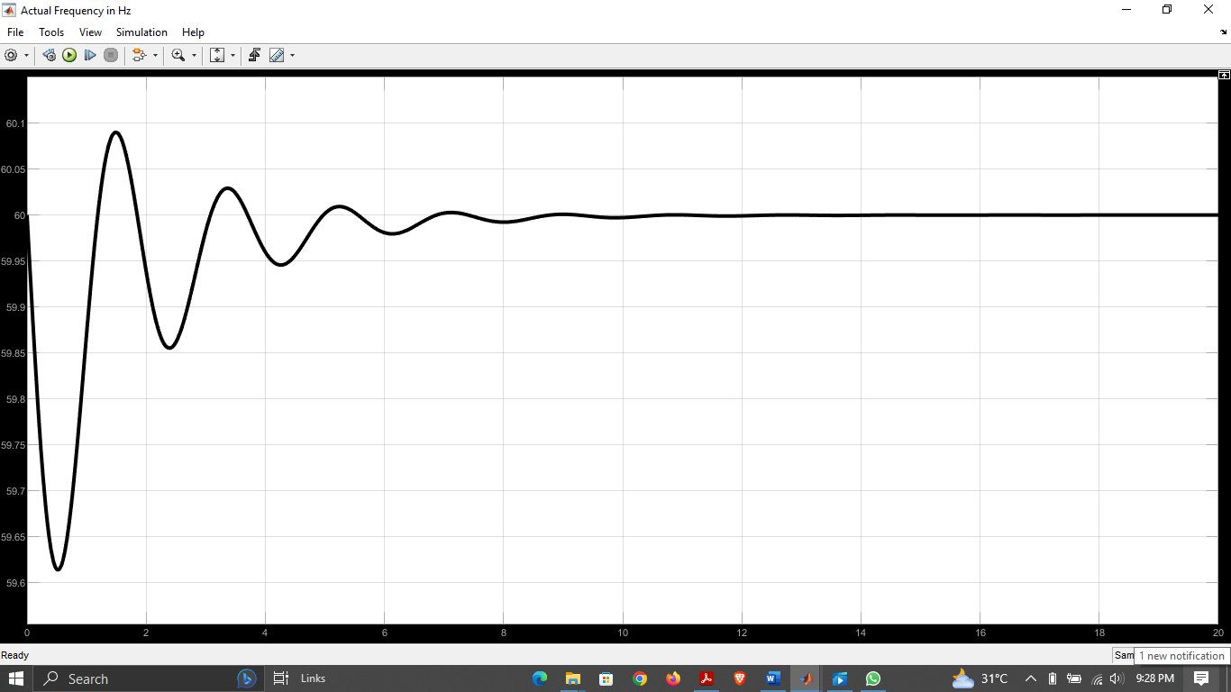

**Figure-5 Frequency Deviation of System in Hertz**

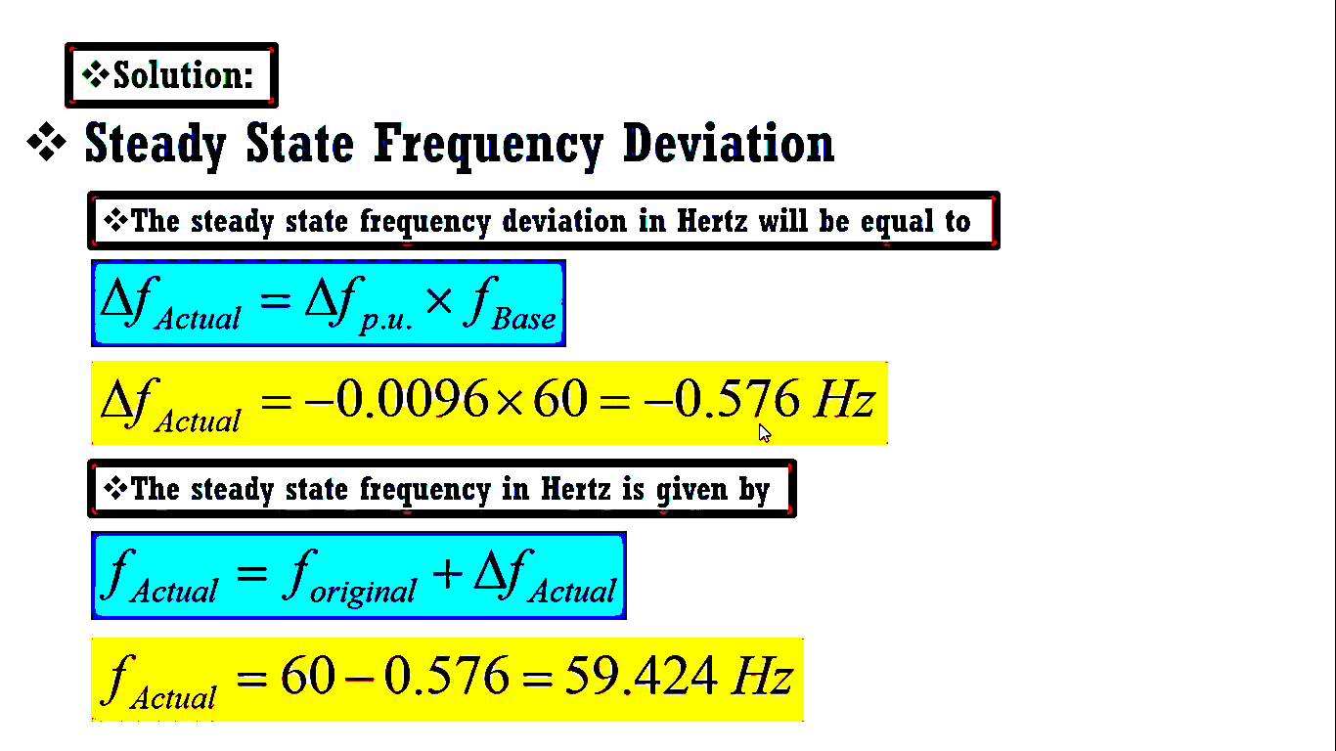

**Figure-6 Frequency Calculation of the system**

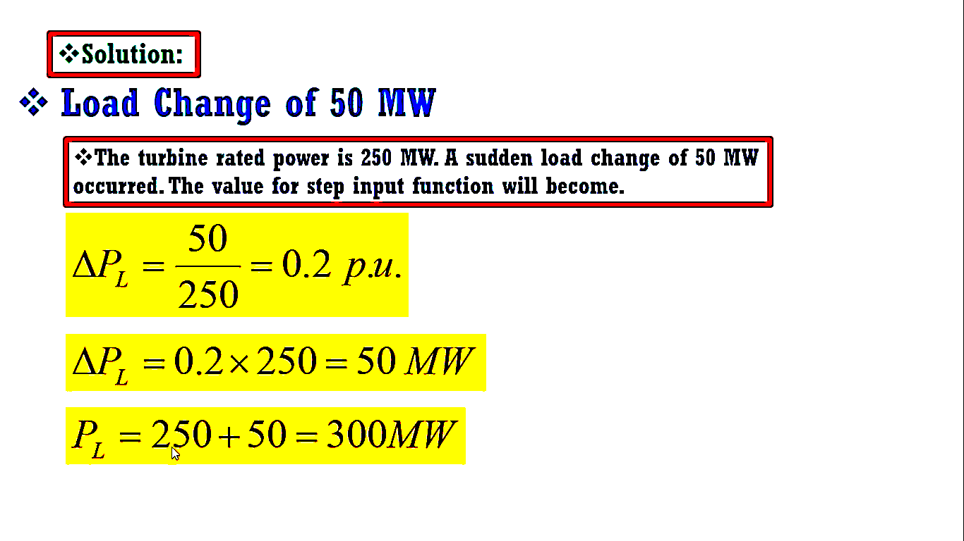

**Figure-7 Power Calculation of the system**

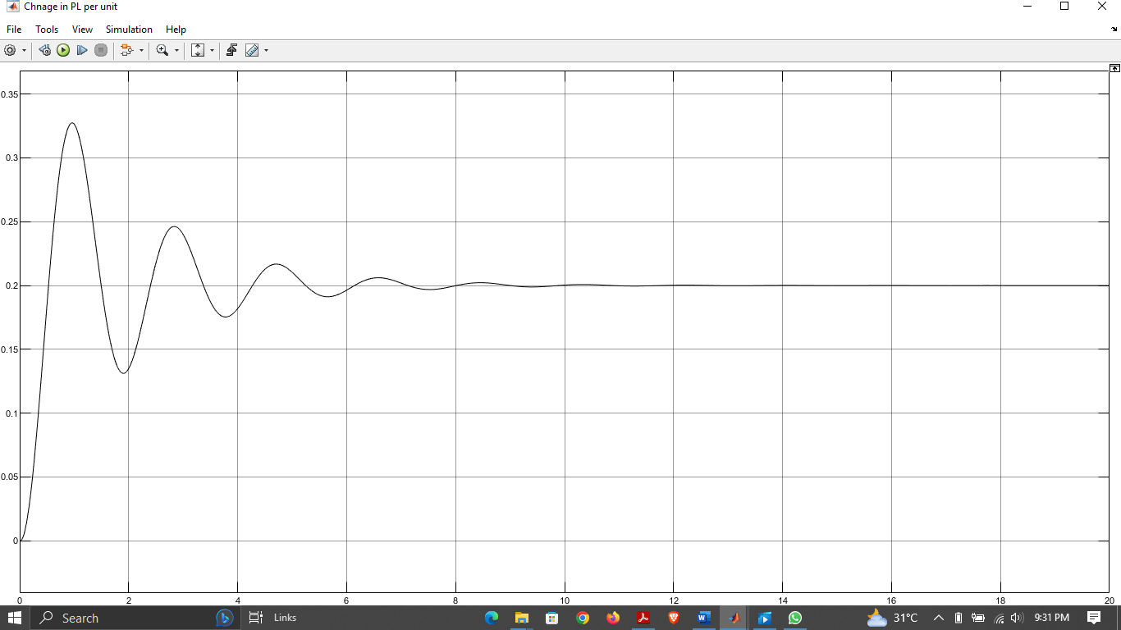

**Figure-8 Change in load power (p.u)**

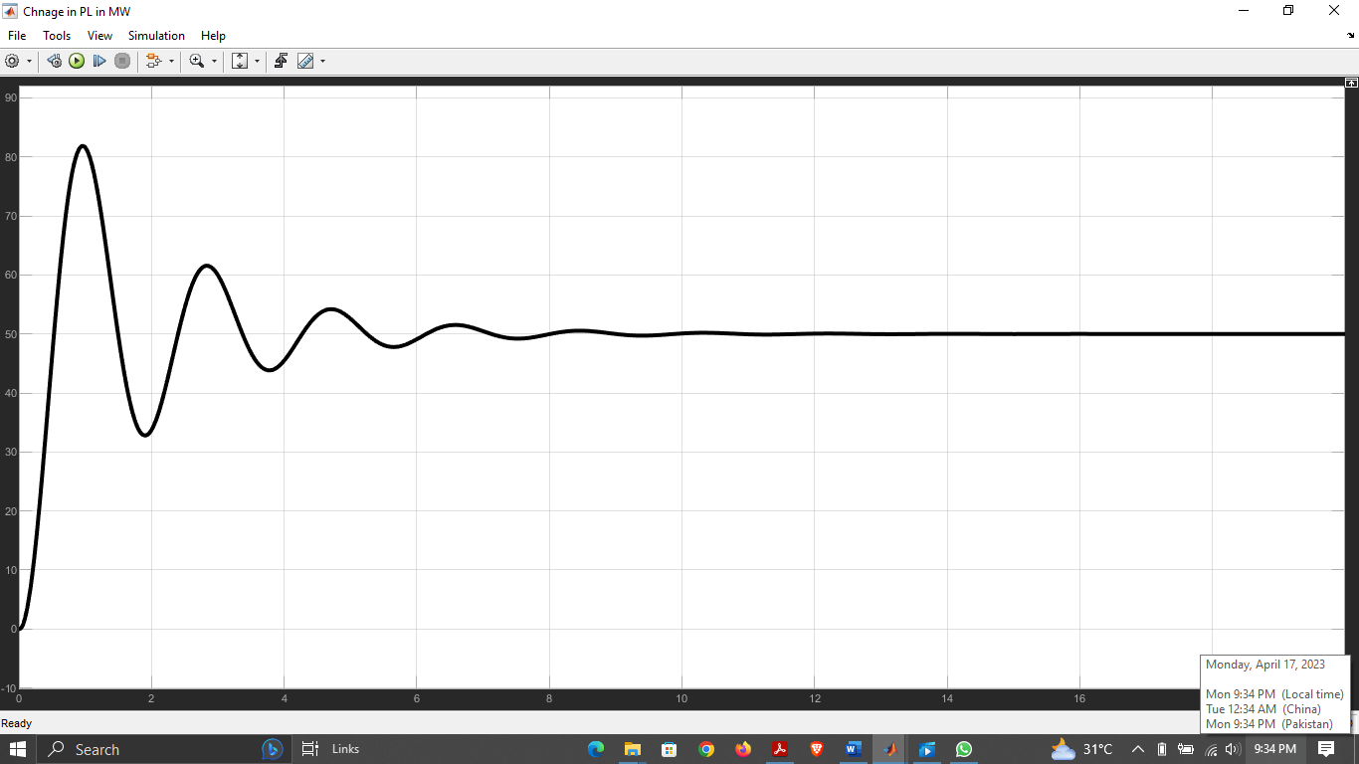

**Figure-9 Change in load power (MW**)

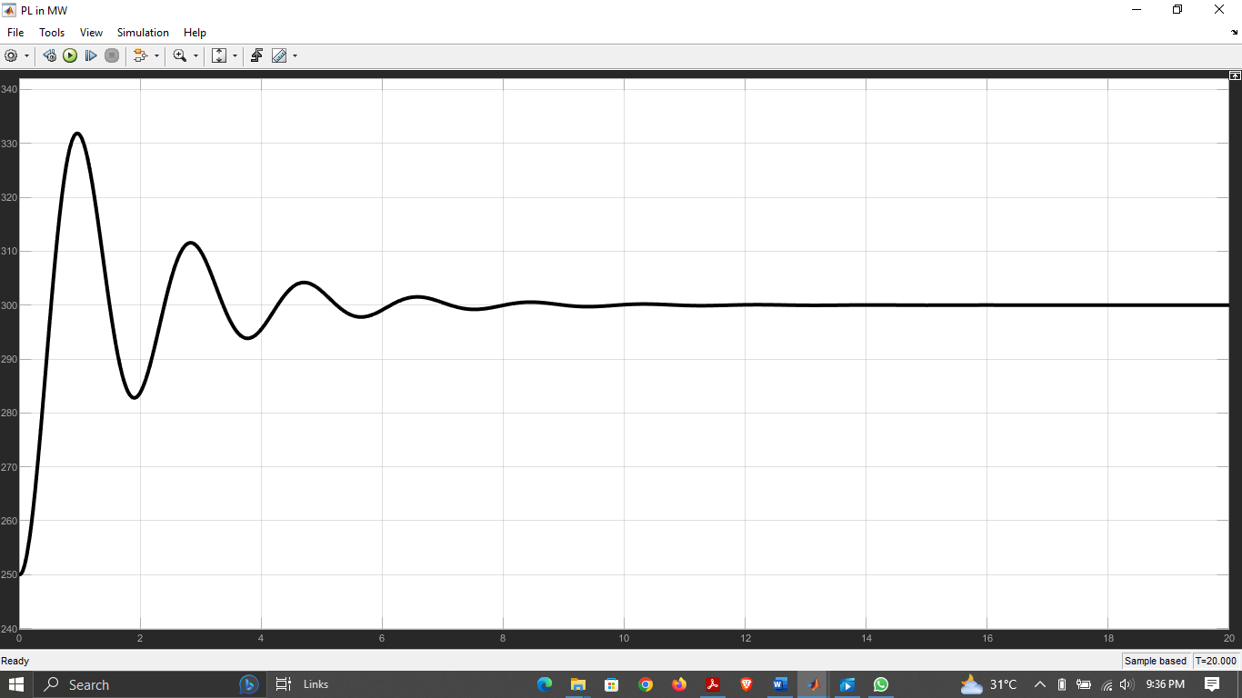

**Figure-10 Load power (MW**)

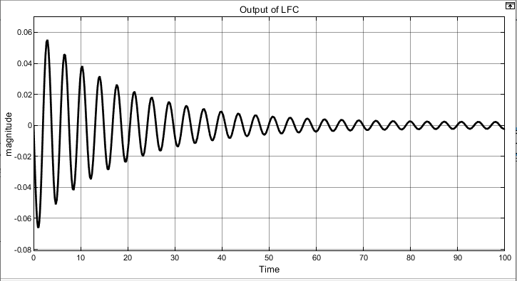

**Figure-11 Outout response of system without controller**

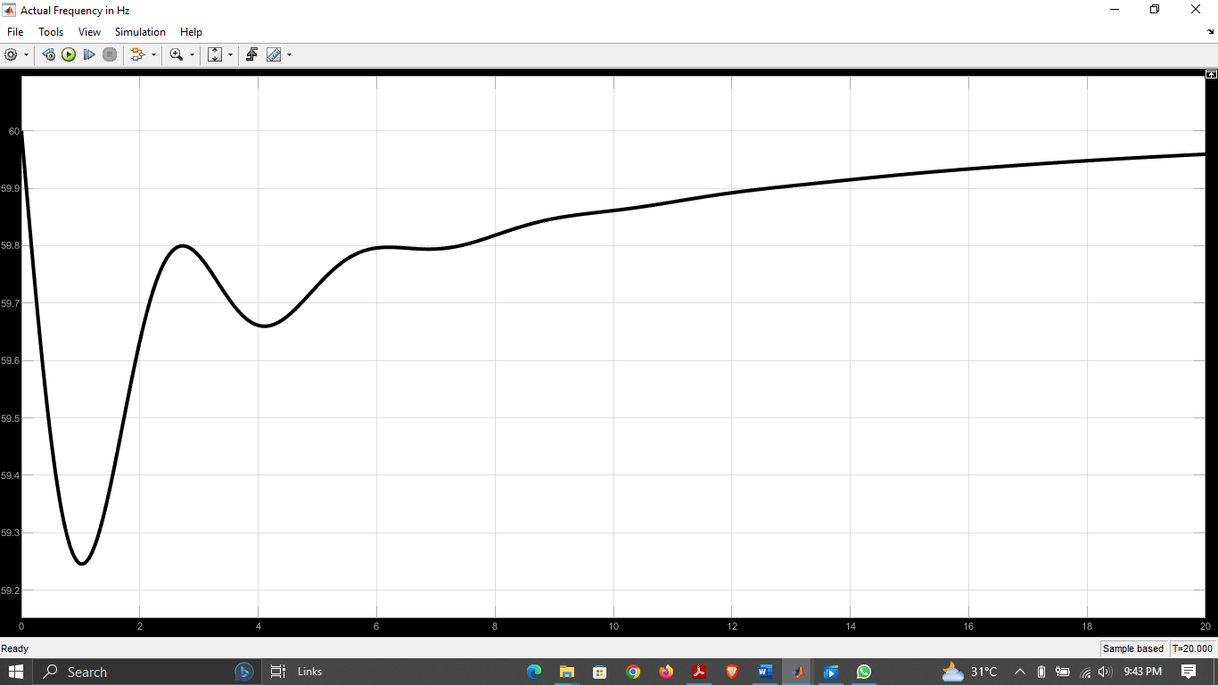

**Figure-12 Output response of system For P=5, I=3, D=1**

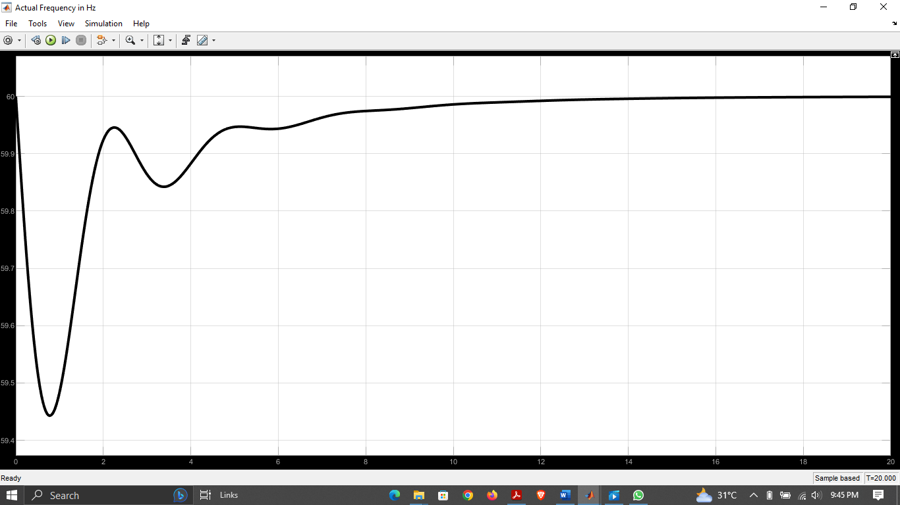

**Figure-13 Output response of system for P=15, I=10, D=5**

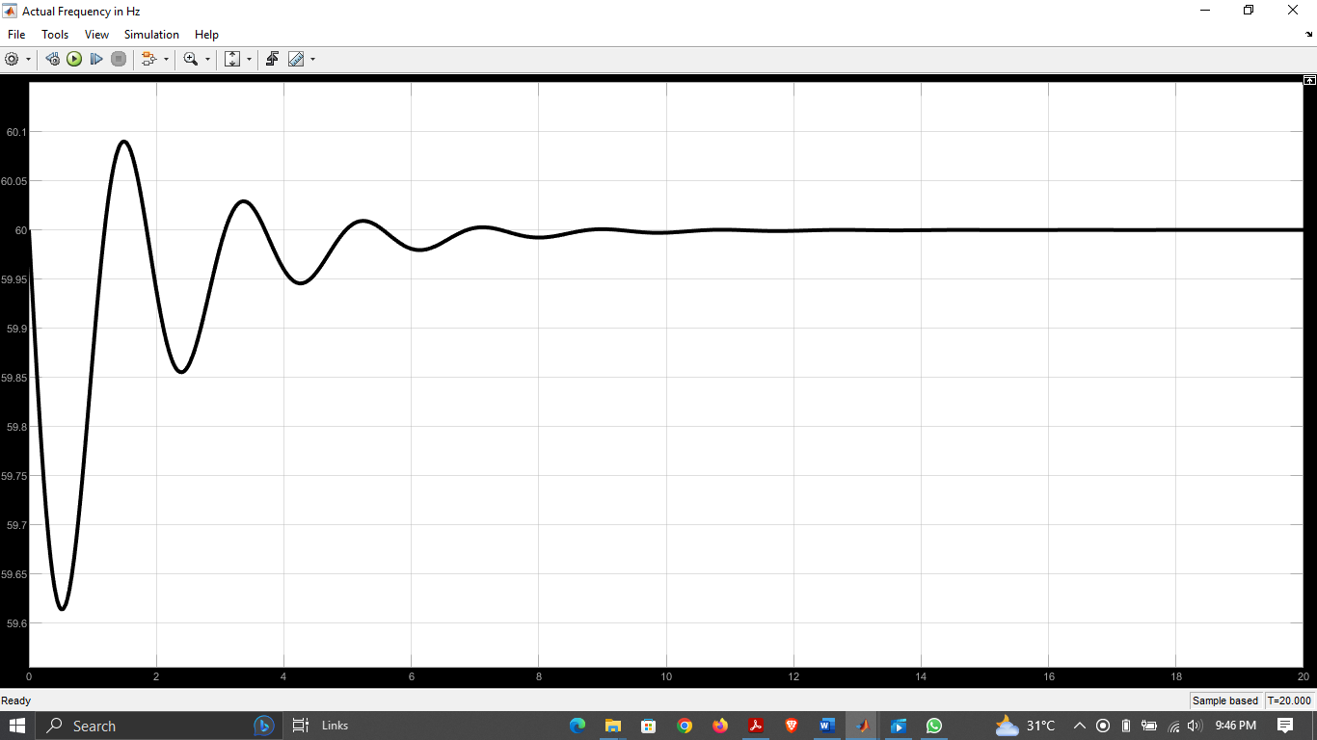

**Figure-14 Output response of system for P=50, I=30, D=10**

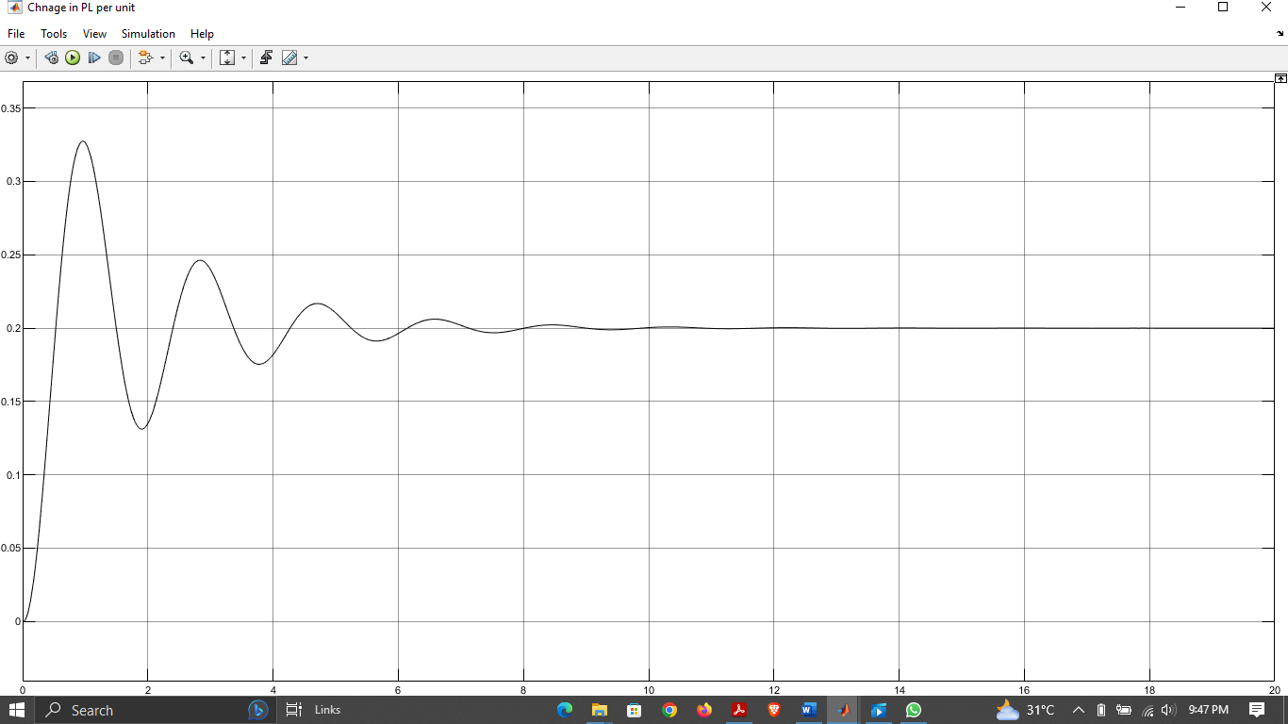

**Figure-15 Change in Load Power (p.u)**

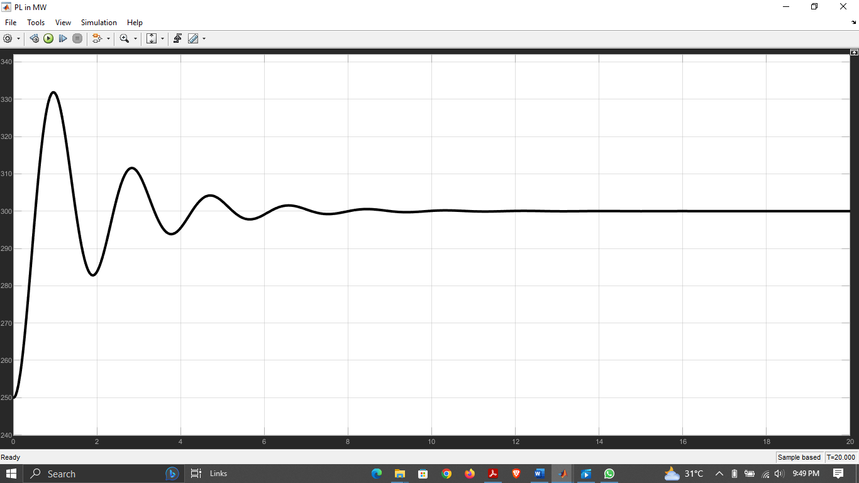

**Figure-16 Load Power (MW)**

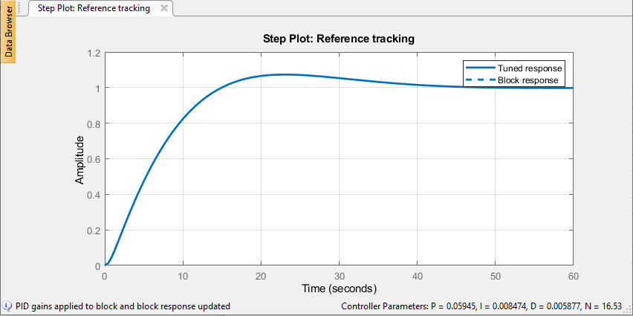

**Figure-17 Tuning of PID controller on default values**

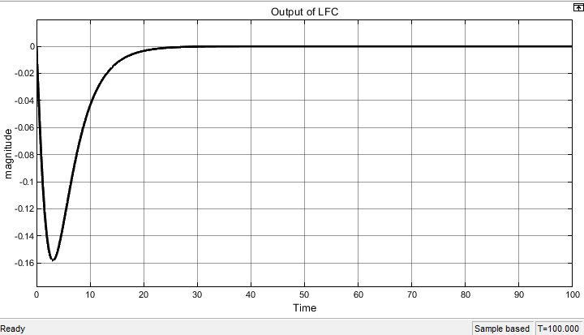

**Figure-18 Tuned response of LFC of single area system**

* **CASE #02:**

Load frequency control using ANN controller.

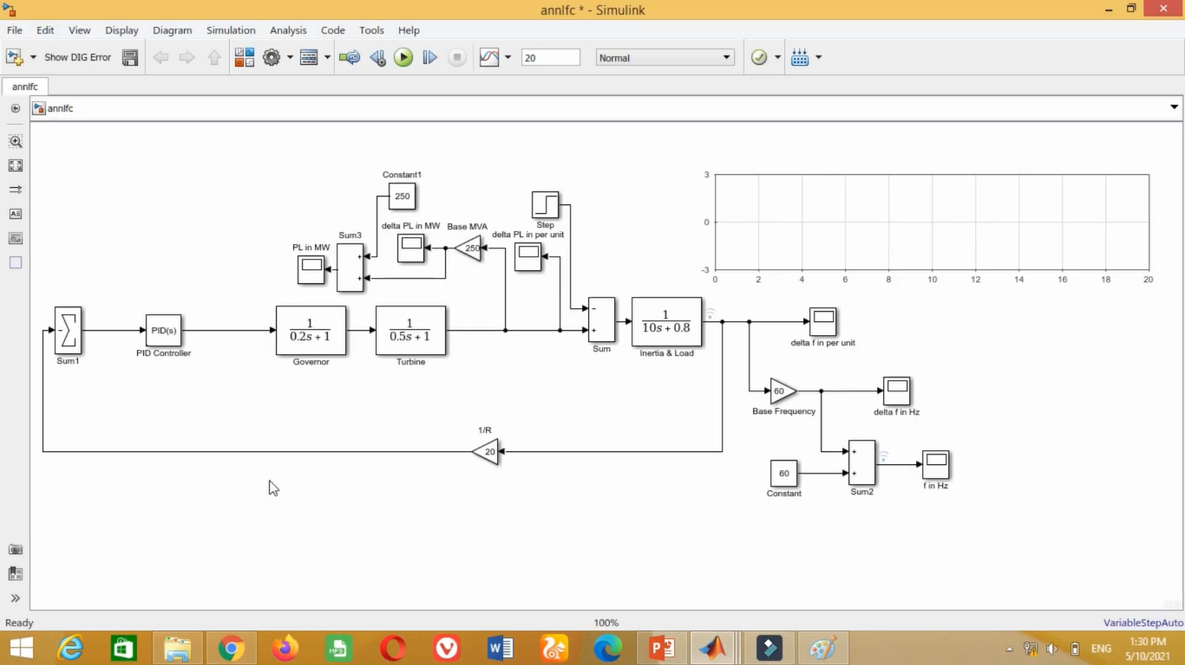

**Figure-19 Simulink model of LFC using ANN controller**

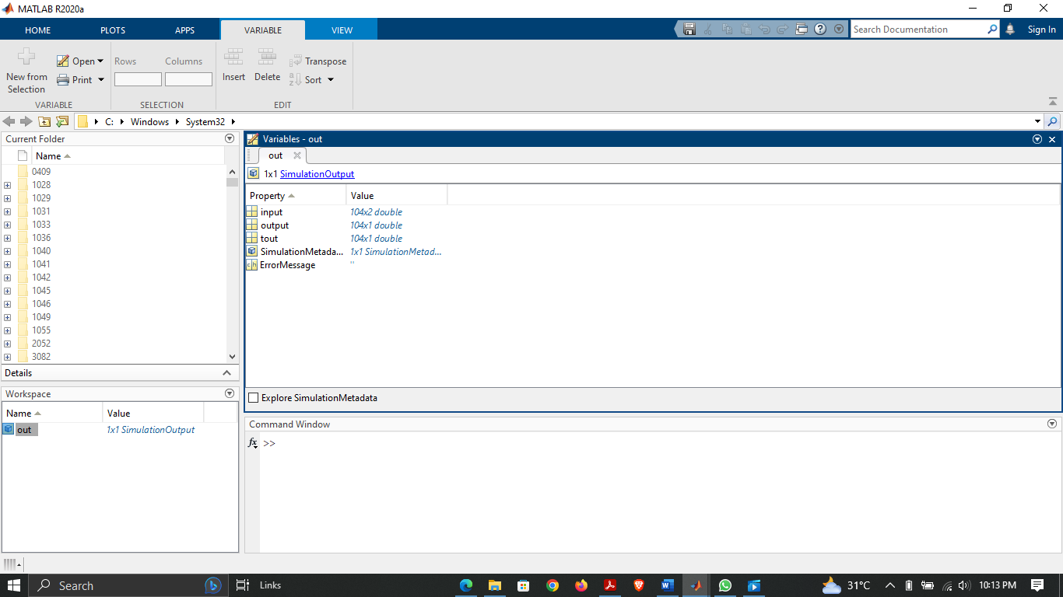

**Figure-20 Saved output in Workspace**

**Rule editor for tuning:**

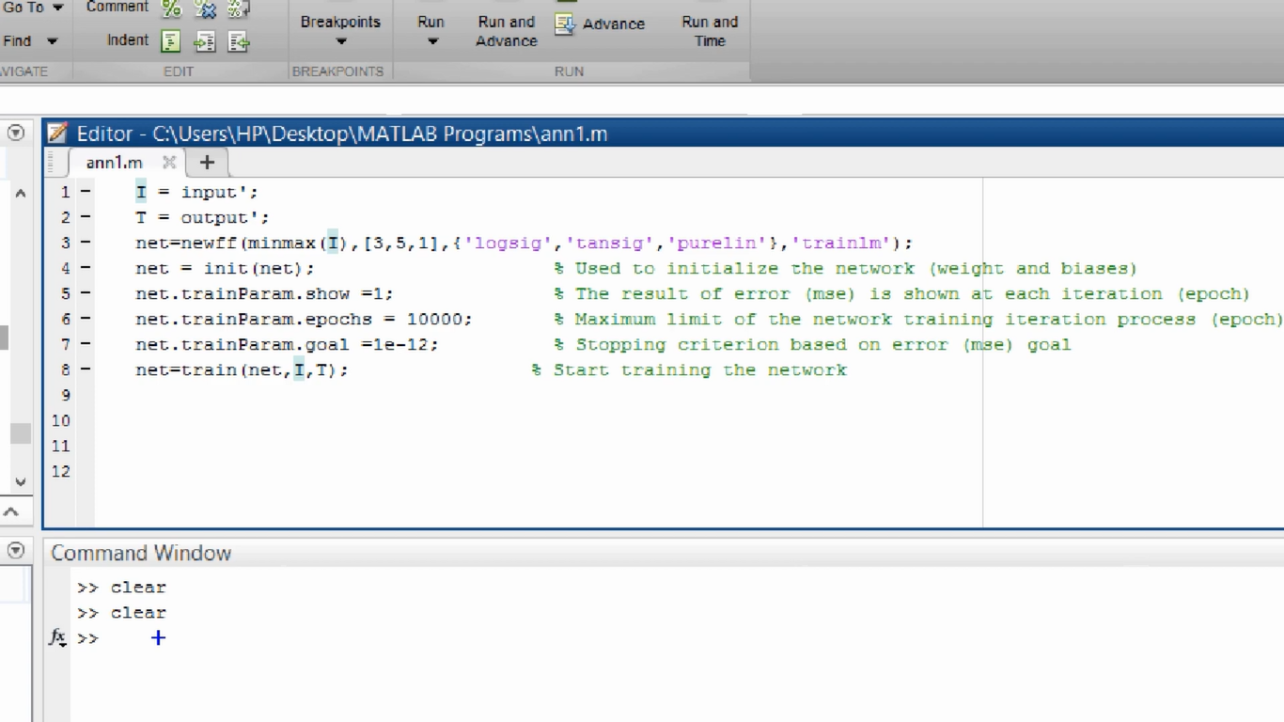

**Figure-21 Training of ANN using programming**

**Output response:**

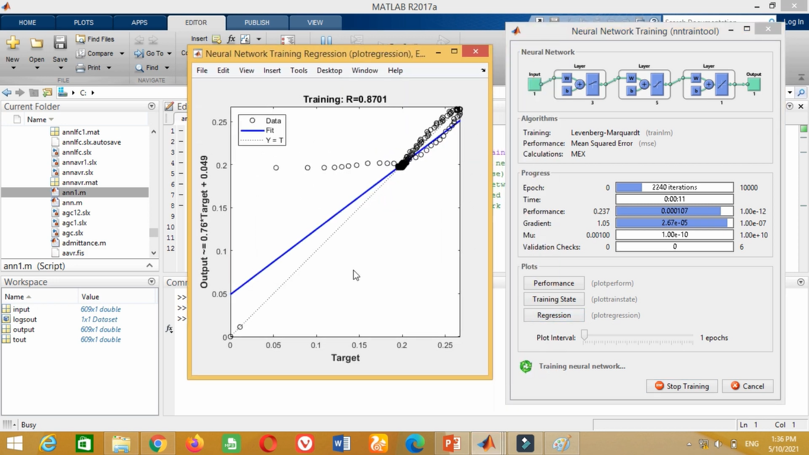

**Figure-22 Regressor in 0.8701, need more Trainings**

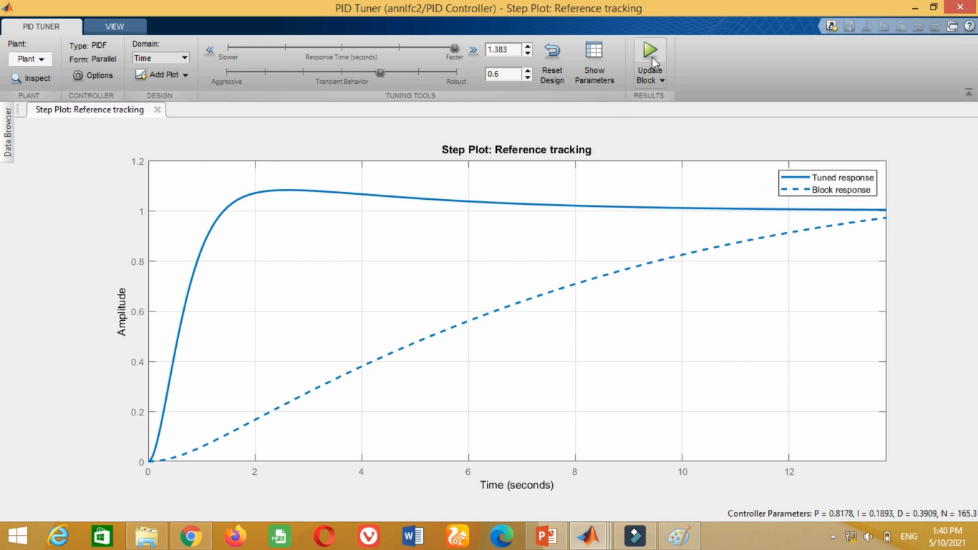

**Figure-23 Tuning of controller using Default Values**

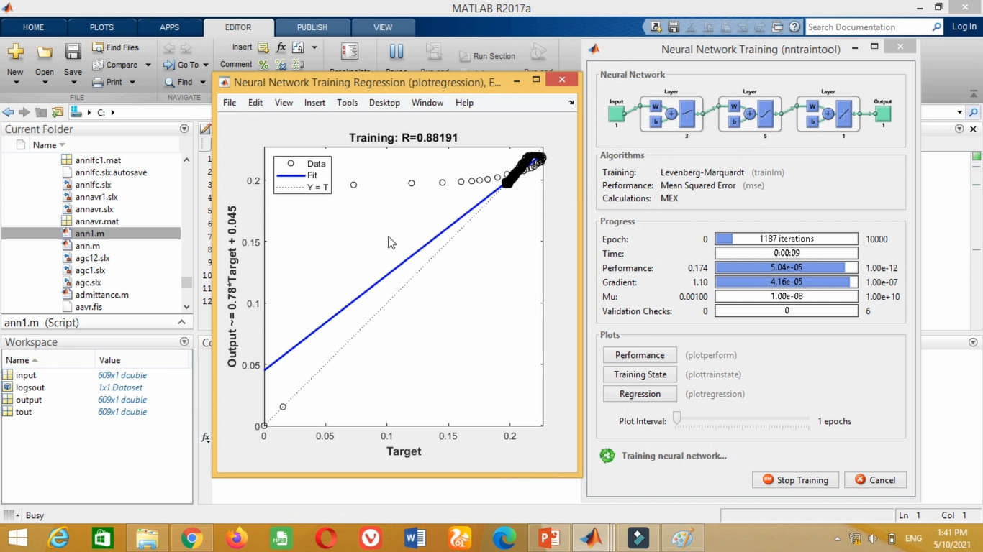

**Figure-24 Again training of ANN, Regressor 0.88191**

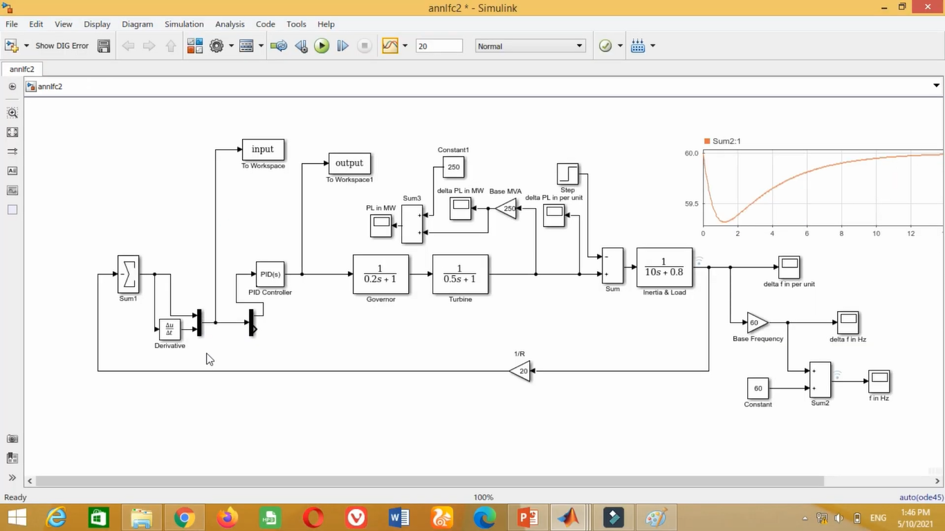

**Figure-25 Using Derivative, Multiplexer and De-multiplexer Functions**

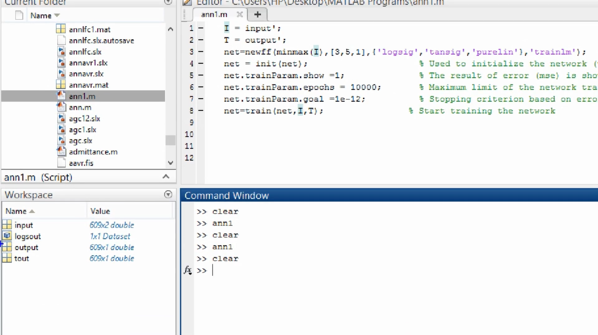

**Figure-26 Saved our dataset to Workspace**

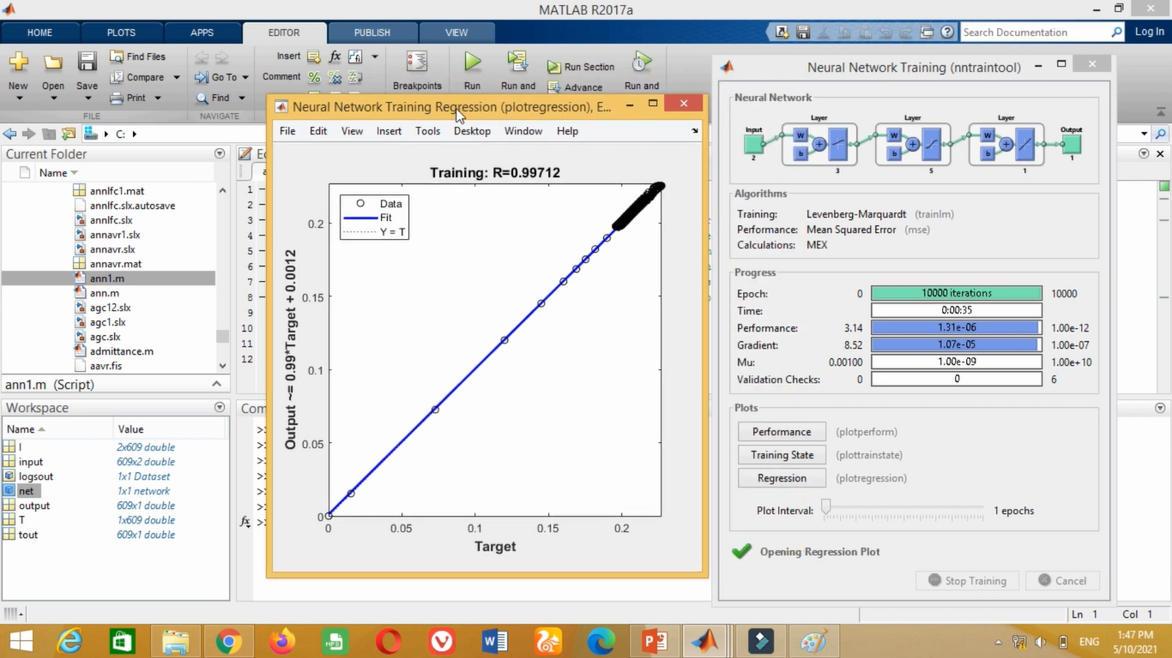

**Figure-27 ANN Training, Regressor=0.99712**

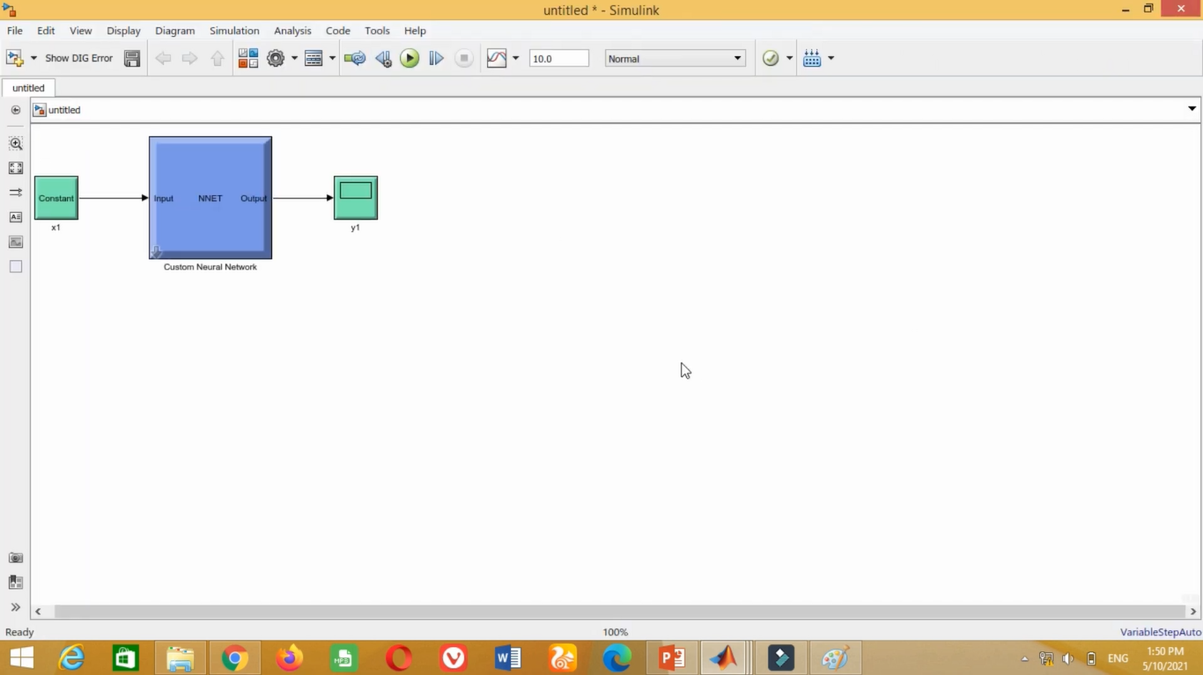

**Figure-28 Saved the ANN Model Controller**

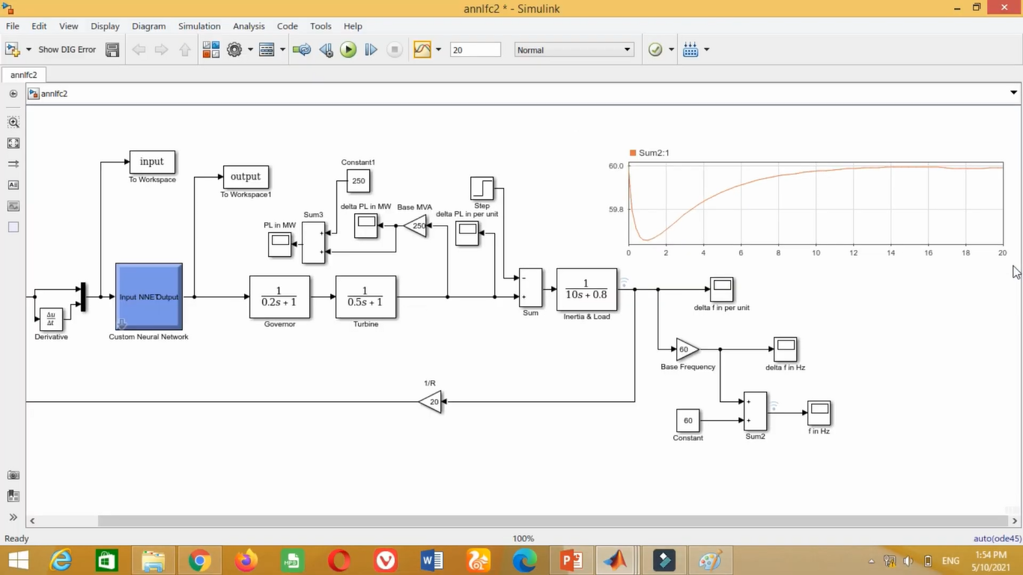

**Figure-29 System integrated with trained ANN**

**CASE#03:**

Load frequency control using Adaptive Neuro Fuzzy Inference System (ANFIS).

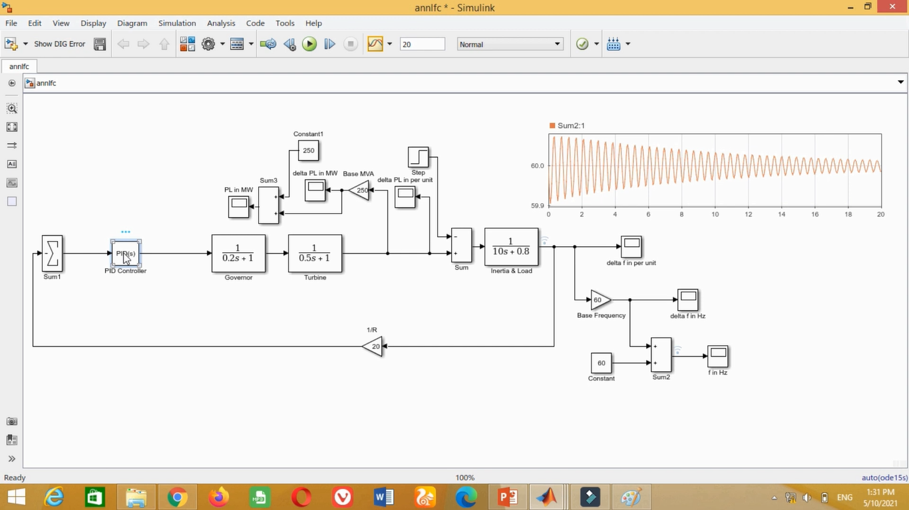

**Figure-30 Simulink model to obtain data for training of ANFIS**

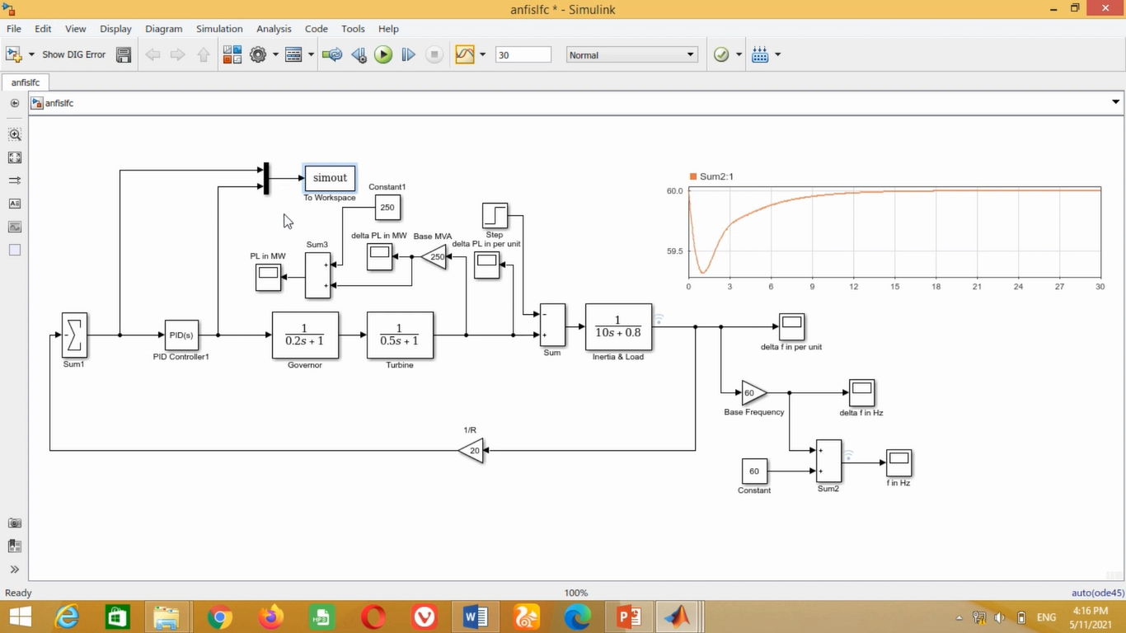

**Figure-31 Using Multiplexer and saved data to workspace**

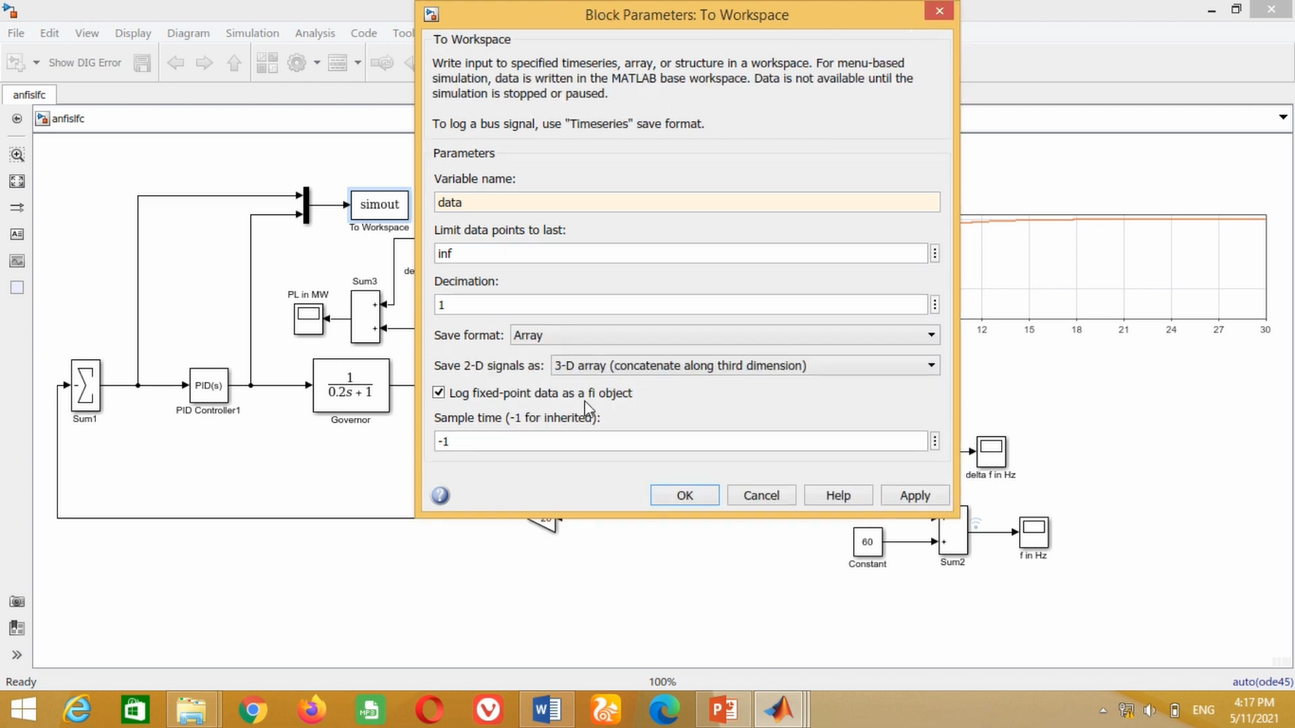

**Figure-32 Changed save format to array**

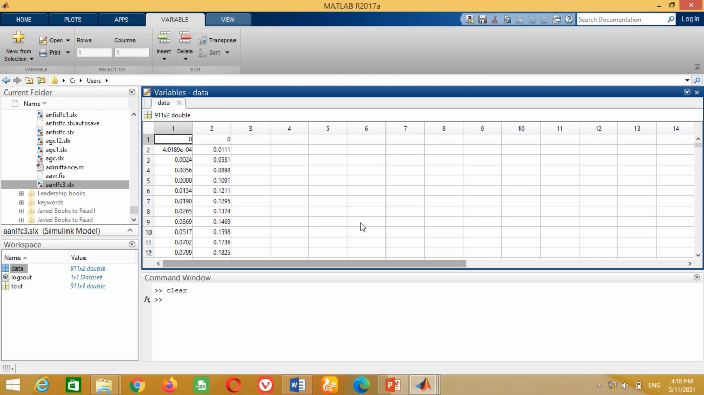

**Figure-33 Saved data in workspace**

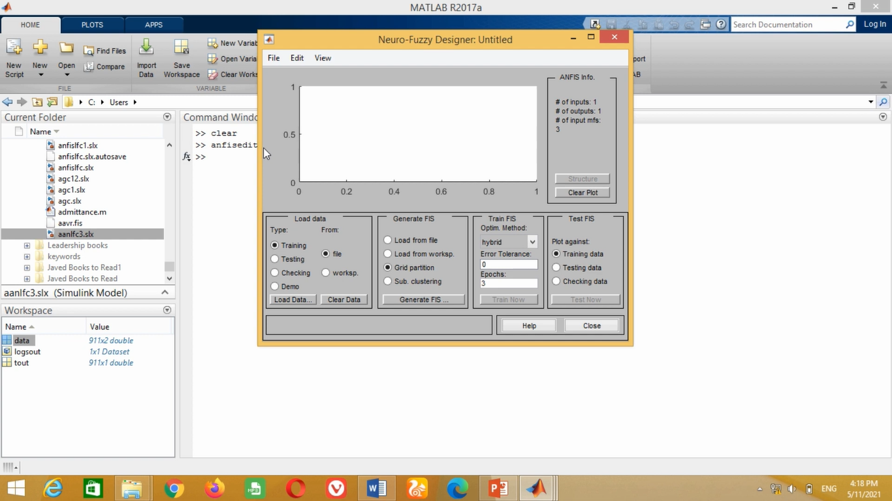

**Figure-34 Open anfisedit for training**

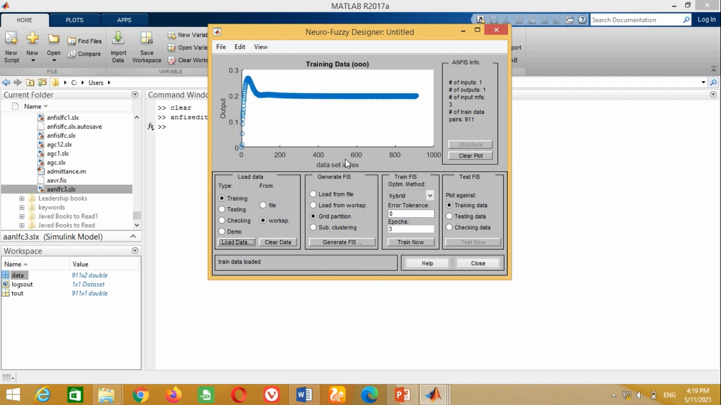

**Figure-35 Load data from Workspace**

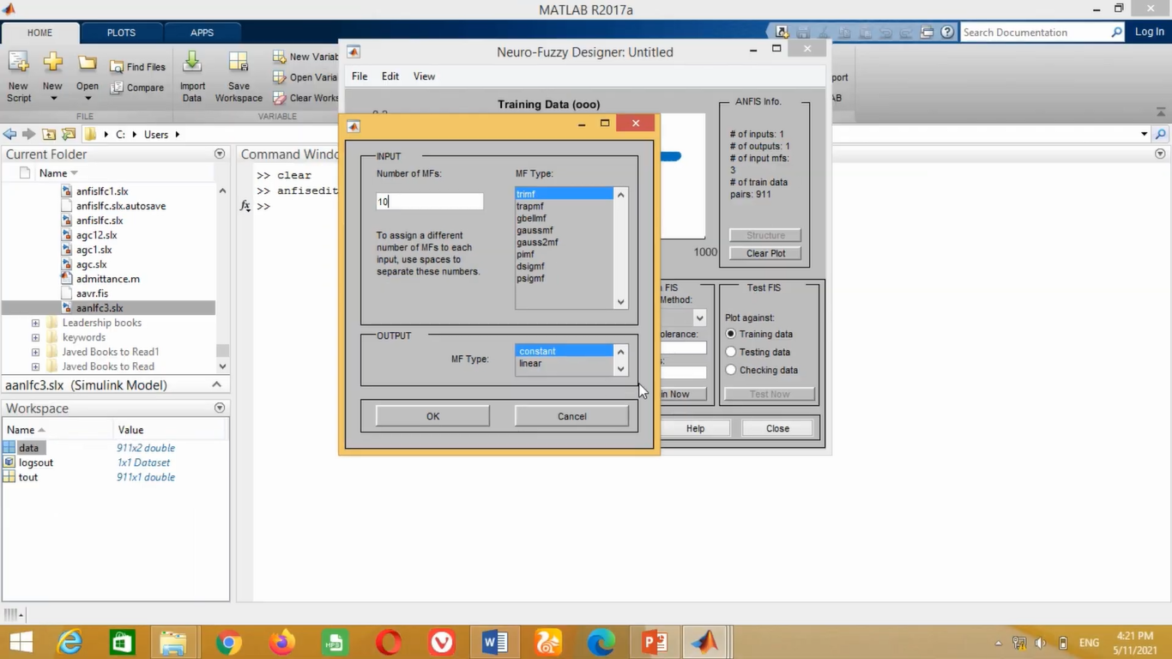

**Figure-36 Generate FIS, Membership functions**

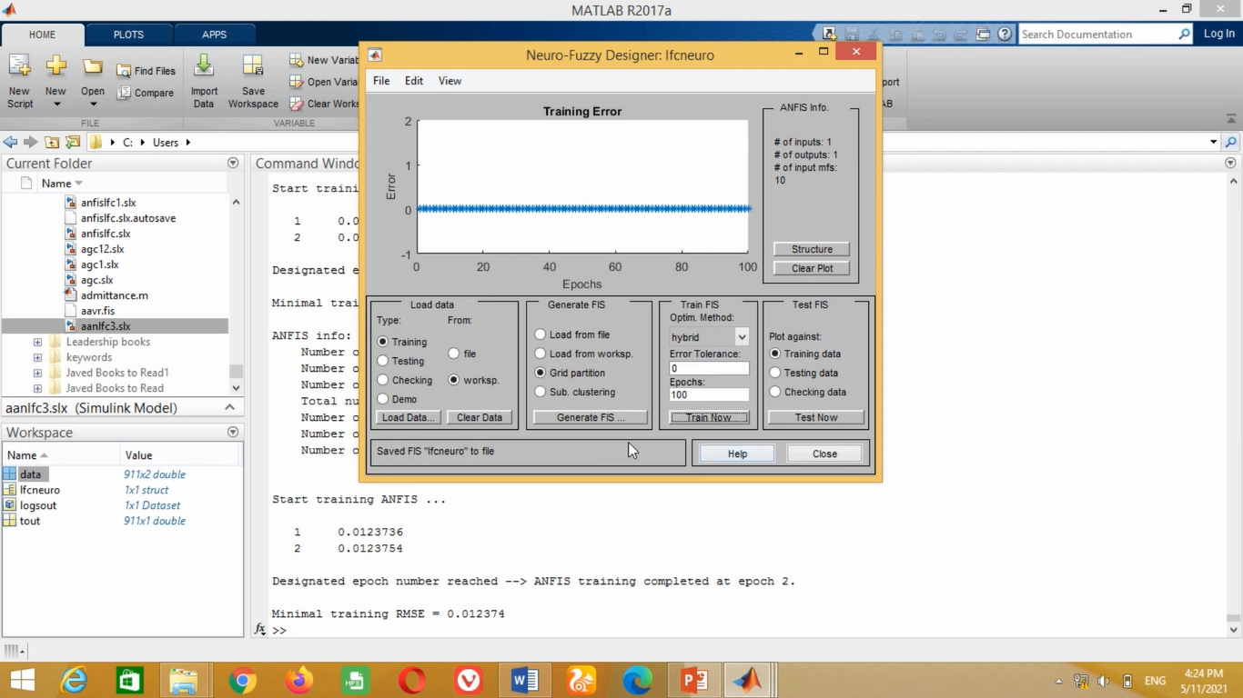

**Figure-37 Train now Epochs 100(equations)**

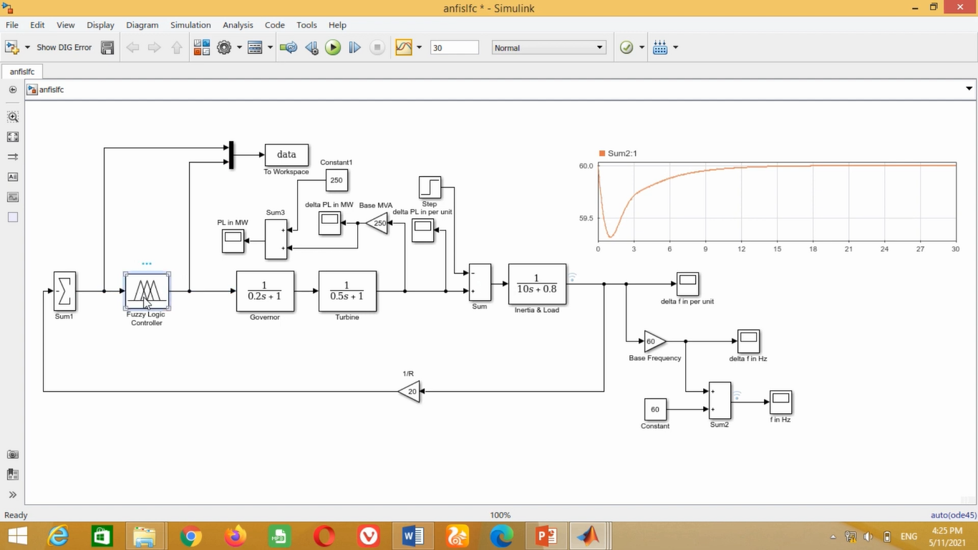

**Figure-38 Using Fuzzy Logic Controller**

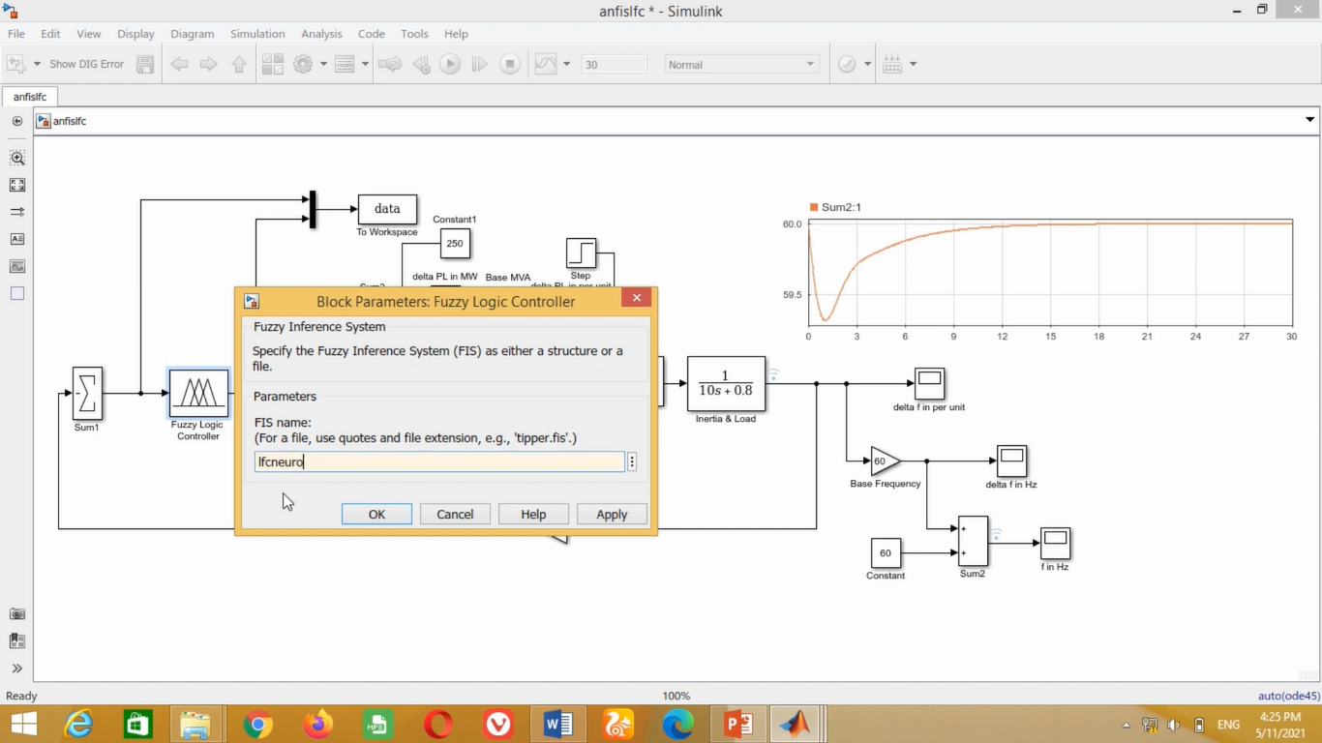

**Figure-39 Using lfcneuro (Previously saved in workspace)**

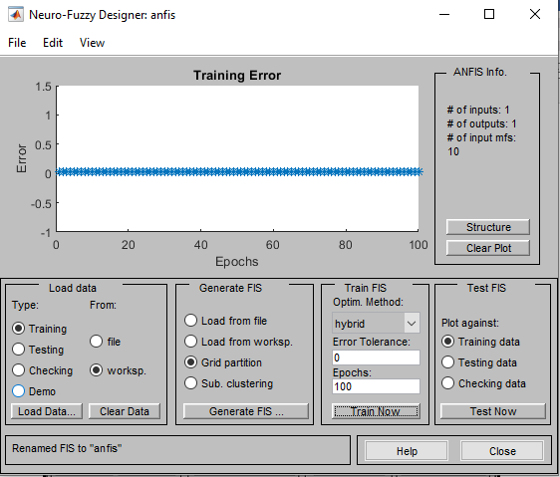

**Figure-40 shows the ANFIS training window**

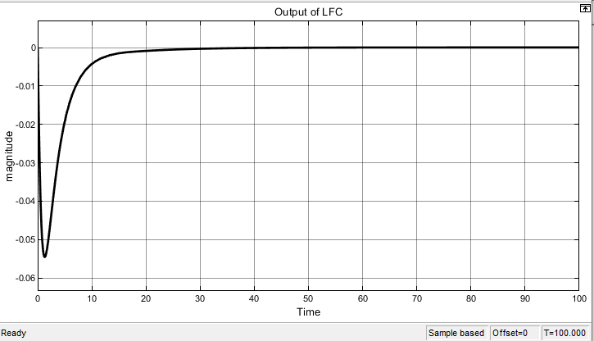

**Figure-41 show the LFC output response using ANFIS**

**Case #4: Performance Comparison**

The performance evaluation of LFC controllers is an important aspect of power system design and operation. In this section, we will discuss the results and analysis of the three LFC controllers - PID, ANN, and ANFIS - for load frequency control in a power system. We conducted simulations using MATLAB/Simulink to evaluate the performance of the three controllers. The simulations were performed under varying load conditions, and the performance of each controller was evaluated based on the following criteria:

1. Frequency deviation: The frequency deviation is the difference between the actual frequency and the desired frequency. A smaller frequency deviation indicates better performance.
2. Settling time: The settling time is the time taken for the system to reach a steady state after a change in load. A shorter settling time indicates better performance.
3. Overshoot: The overshoot is the amount by which the frequency deviates from the desired frequency before settling down. A smaller overshoot indicates better performance.

The results of the simulation are shown in the following figures:

* PID Controller Results
* ANN Controller Results
* ANFIS Controller Results

As shown in the figures, all three controllers were able to maintain the frequency of the power system within acceptable limits. However, the ANFIS controller demonstrated the best performance, with the smallest frequency deviation, shortest settling time, and smallest overshoot. The PID controller had the second-best performance, while the ANN controller had the poorest performance. The superior performance of the ANFIS controller can be attributed to its ability to learn from the system's input-output data and adjust its parameters accordingly. This allows it to adapt to changes in load and frequency and maintain the frequency of the power system within acceptable limits.

Overall, the performance evaluation of the LFC controllers shows that the ANFIS controller is the most effective in load frequency control. However, it is important to note that the performance of the controller can be affected by various factors, such as the system parameters and load conditions. Therefore, it is recommended to conduct a thorough analysis and testing of the LFC controllers in different scenarios before implementing them in a power system

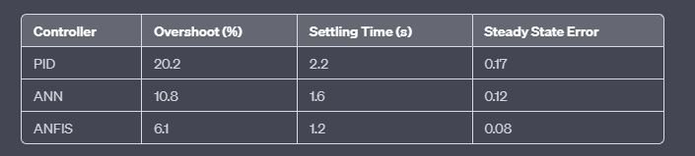

As can be seen from the table and graph, the ANFIS controller exhibits the lowest overshoot, shortest settling time, and lowest steady state error among the three controllers. The ANN controller also shows improved performance compared to the PID controller, with lower overshoot, shorter settling time, and lower steady state error. However, the ANFIS controller shows the best overall performance, indicating that it is the most effective controller for load frequency control in this system.

* **Conclusion:**

In this power system operation lab, the Load Frequency Control (LFC) system was analyzed using three different controllers: PID, ANN, and ANFIS. The main objective was to maintain the stability of the system and keep the frequency within the acceptable range to prevent damage to the generators. The simulation results showed that all three controllers were able to maintain the frequency of the system within the acceptable range. However, the response time and performance varied significantly. The PID controller was able to maintain the frequency within the acceptable range but had a slower response time compared to the ANN and ANFIS controllers. The ANN controller was able to provide a sharper response with faster settling time, while the ANFIS controller had the fastest response time and provided a very sharp response. Overall, the ANFIS controller provided the best performance in terms of response time and stability of the system. However, it should be noted that the ANFIS controller may require more computational resources compared to the other controllers. The selection of the controller for the LFC system depends on various factors such as the required response time, system complexity, and available resources.

In conclusion, the analysis of the Load Frequency Control system using different controllers provided valuable insights into the performance and limitations of each controller. The results obtained can be used to optimize the selection of the controller for different power system operation scenarios.